Baldivis Secondary College 2016

Year 9 Semester 2 Exam
Question/Answer Booklet

Student Name: _______________________________________

Teacher: ________________________________________

Time allowed for this paper
Reading time before commencing work: ten minutes
Working time for paper: one hours

Materials required/recommended for this paper
To be provided by the supervisor
This Question/Answer Booklet Mathematics Formula Sheet

To be provided by the candidate

Standard items: pens (blue/black preferred), pencils (including coloured), sharpener,
correction fluid/tape, eraser, ruler, highlighters
Special items: one non-programmable calculator approved for use in the WACE examinations
1 A4 formula sheet made by student, both sides

Important note to candidates
No other items may be taken into the examination room. It is your responsibility to ensure that you do not have any unauthorised notes or other items of a non-personal nature in the examination room. If you have any unauthorised material with you, hand it to the supervisor before reading any further.

Year 9 Semester 2 Mathematics Exam
Structure of this paper

Section | Number of questions available | Number of questions to be answered | Suggested working time (minutes) | Marks available | Percentage of exam
Section One: Multiple-choice | 19 | 19 | 20 | 36 | 40
Section Two: Extended answer answer | 3 | 3 | 40 | 52 | 60
 |  |  |  |  | 100

Total________/88 _________%

Instructions to candidates

- The rules for the conduct of Western Australian external examinations are detailed in the Year 12 Information Handbook 2016. Sitting this examination implies that you agree to abide by these rules.

- Answer the questions according to the following instructions.

Write your answers in this Question/Answer Booklet. Use only a blue or black pen to shade the boxes. If you make a mistake, place a cross through that answer, then circle your new answer. Do not erase or use correction fluid/tape. Marks will not be deducted for incorrect answers. No marks will be given if more than one answer is completed for any question.

- When calculating numerical answers, show your working or reasoning clearly. Express numerical answers to the appropriate number of significant figures (normally 2dp) and include appropriate units where applicable.

4. You must be careful to confine your responses to the specific questions asked and to follow any instructions that are specific to a particular question.

- The Mathematics Formula Sheet is to be handed in with your Question/Answer Booklet.

Multiple Choice Section:
Identify the choice that best completes the statement or answers the question.
19 multiple-choice questions
2 marks each: 36 marks Total :______________________/36
Circle the correct answer

1 A normal die has six faces numbered from 1 to 6. What is the sample space?
A {1, 6} B {6}
C {1, 2, 3, 4} D {1, 2, 3, 4, 5, 6}
2 What is the probability of an impossible event?
A 0 B 0.5 C 0.75 D 1
3 What is the probability of a certain event?
A 0 B 0.5 C 0.75 D 1

Questions 4 and 5 refer to the following tree diagram. You may assume all branches are equally likely.
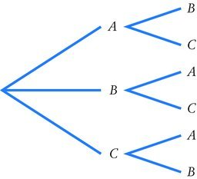
4 What is the probability of getting B followed by C?
A B C D
5 What is the probability of getting an A and a B in any order?
A B C D

6 What is the probability that if a letter is
chosen at random from the letters in the word PROBABILITY, it will be a B or an I?
A $\frac{4}{11}$ B
C D
7 The probability that Joan will win her race is
0.35. What is the probability she will not win
her race?
A 0.35 B 0.5
C 0.65 D 0.75
8 What can be said about the gradient of the following line?
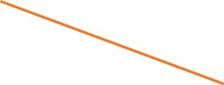
A It is positive. B It is negative.
C It is zero. D It is undefined.
9 Use the grid below, or the formula, to find the mid-point of the line joining (−3, −4) and (2, 2).
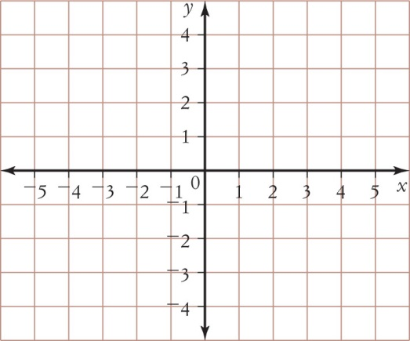
A (⁻1, ⁻1) B (⁻1, 1)
C D
10 What is the gradient of the line x = 3?
A 0 B ⁻3
C 3 D undefined

11 What is the gradient of the line y = 5?
A | 5 | C | –5
B | undefined | D | 0

12 What can be said about the gradient of the line below?
A | It is negative. | C | It is undefined.
B | It is zero. | D | It is positive.

13 Expand 3(2t + 5).
A 5t + 8 B 6t + 8
C 6t + 5 D 6t + 15

14 Expand and simplify (x + 3)(x + 5).
A x2 + 3x + 5 B x2 + 8x + 15
C x2 + 3x + 15 D x2 + 15x + 8

15 Find the highest common factor of 24ax3y2 and 18axy2.
A 3ax2y B 6axy2
C 6ax2y2 D 6ax2y
16 Factorise 4i – 10.
A 4(i – 10) B 4(i – 5)
C 2(i – 5) D 2(2i – 5)

17 Expand 3a(2a – 5b).
A 6a – 5b B 6a2 – 5b
C 6a2 – 15ab D 6a – 15ab
18 Expand –n(n + 2).
A –n2 – 2 B –n2 – 2n
C –n2 + 2 D –n2 + 2n
19 Expand (2t – 4)(5t – 3).
A 10t2 – 26t + 12 B 10t2 – 26t – 12
C 10t2 – 14t + 12 D 10t2 + 14t – 12

Written Questions (52 Marks)

1.
(5 Marks)
a) Assuming that the chances of a head or tail is equal, use a tree diagram or a two-way table to determine the following theoretical probabilities for the tossing of two coins:
i) P(2 heads) ii) P(1 head & 1 tail) iii) P(2 tails)

(6 Marks)
b) Determine the following theoretical probabilities of the totals
when tossing two dice.
i) P(5 or odd) ii) P(5 and odd)
iii) P(<10 or even) iv) P(odd or divisible by 3)

 | 1 | 2 | 3 | 4 | 5 | 6
1
2
3
4
5
6

c) In a class of 21 students, 16 students passed Maths, and 15 students passed English.
(5 Marks)
Two Students passed neither. Draw a Venn Diagram and find the probability that a student:
i) passed Maths and English. ii) passed Maths or English. iii) Failed English

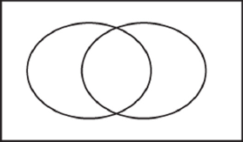

2.
(4 Marks)
a) Find the length, gradient, and midpoint of AB

i)
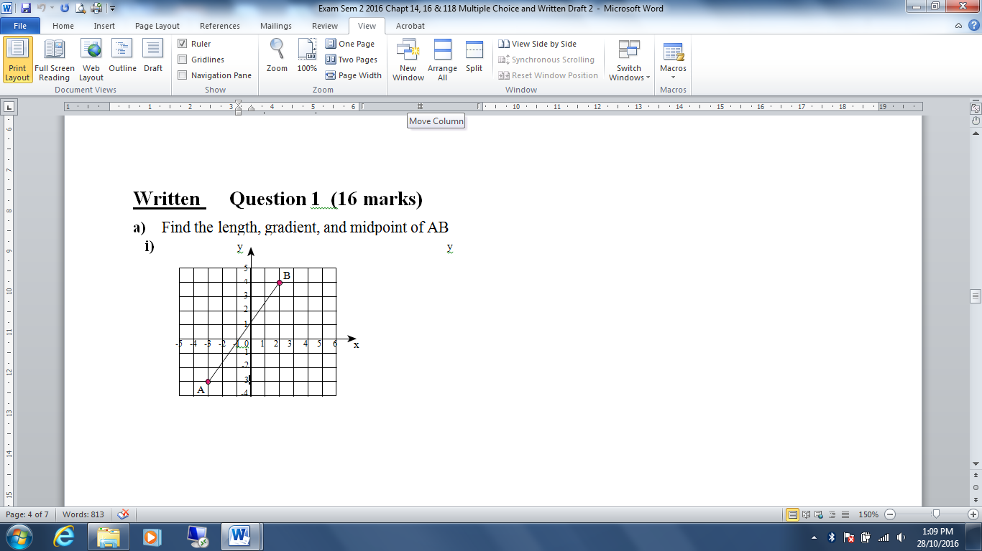

ii) A(-4,4), B(2,-3)
(5 Marks)


(7 Marks)
b) A parallelogram has the four endpoints A(-4,-5), B(-7,-1), C(-5,0), D(-2,-4).

- Show that AB is parallel to CD.
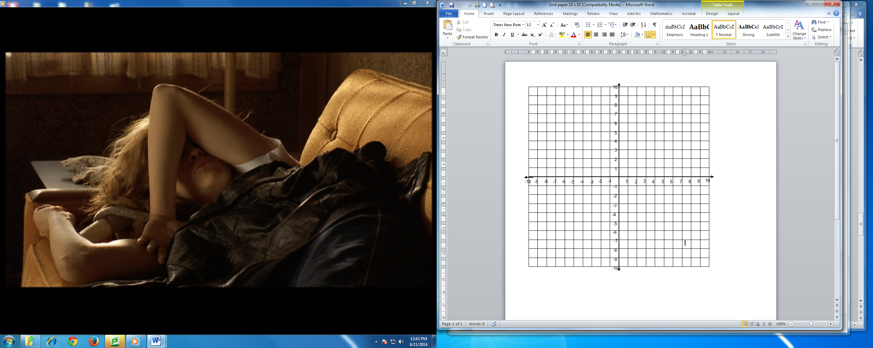

ii) Show that the opposite sides are equal in length.

3.
a) Simplify the following expressions:
(4 Marks)

i) 3x − 7x ii) 5a + 4b − 2a + 2b iii) 8b⁴ × (−4b²) iv) −6d ÷ 3

b) Expand each of the following:
(2 Marks)

i) 3(x + 2) ii) −5x(x − 3)

(8 Marks)
c) Simplify each of the following by expanding and then collecting like terms:

i) −3(x − 3) + 2(x + 2) ii) (x + 2)(x + 1) iii) (x + 2)(x – 2) iv) (x+3)²

(8 Marks)
d) Factorize each of the following:

i) 4x + 10 ii) 4t² − 12t iii) −2x³ − 12x iv) x(x − 1) + 5(x − 1)

